Lab2:

**Step 1: Modify a File Locally**

1. Open **Notepad** (or any text editor) on your local system.
2. Edit the **index.html** file and save the changes.

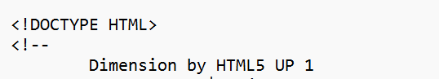

1. Click on upload, and upload the doc again

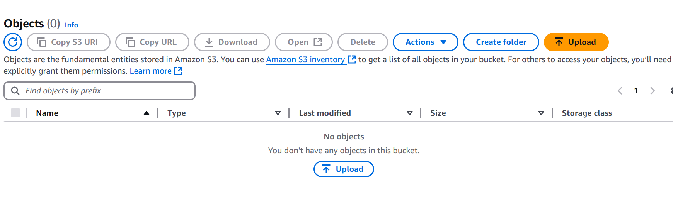

**Step 2: Upload the Modified File to S3**

1. Go to the **AWS Management Console**.
2. Navigate to **S3** and open your bucket.
3. Click **Upload**.
4. Click **Add Files**, select the modified index.html, and upload it.

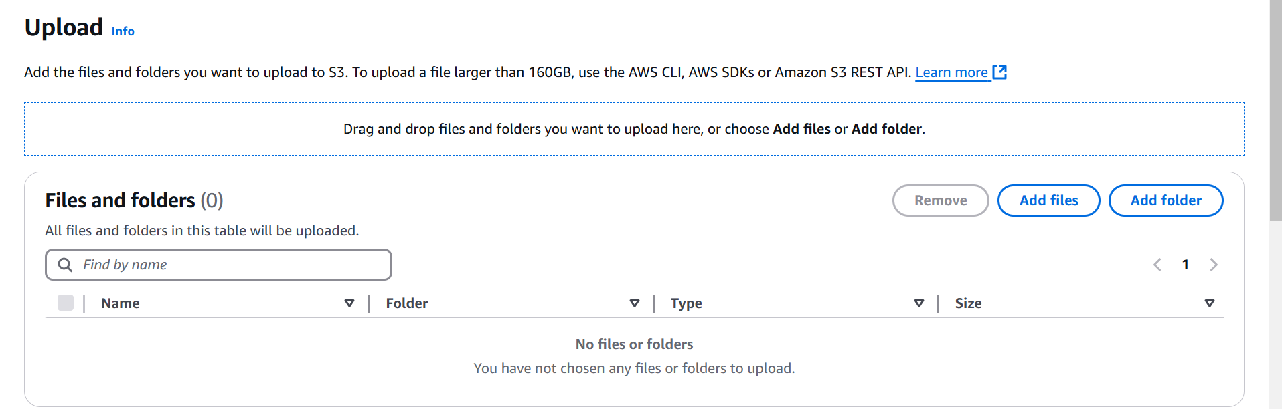

**Step 3: Enable Versioning**

1. In the S3 bucket, click on **Properties**.
2. Scroll down to the **Versioning** section.
3. Click **Edit** and enable **Bucket Versioning**.
4. Save the changes.

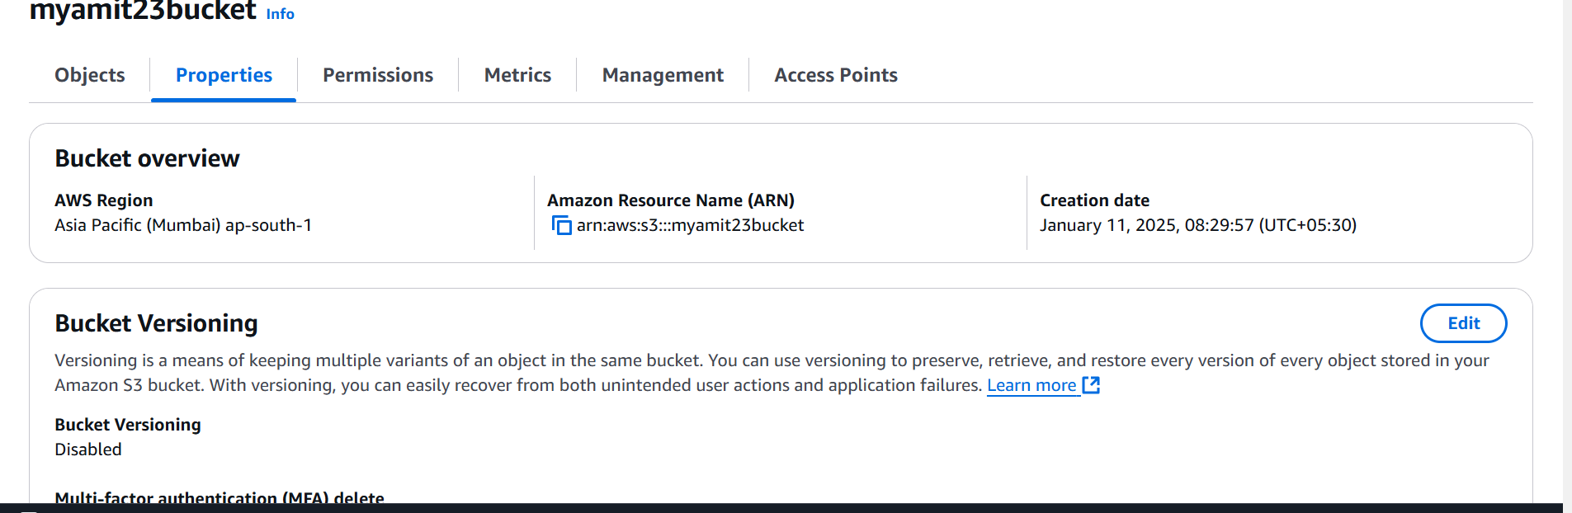

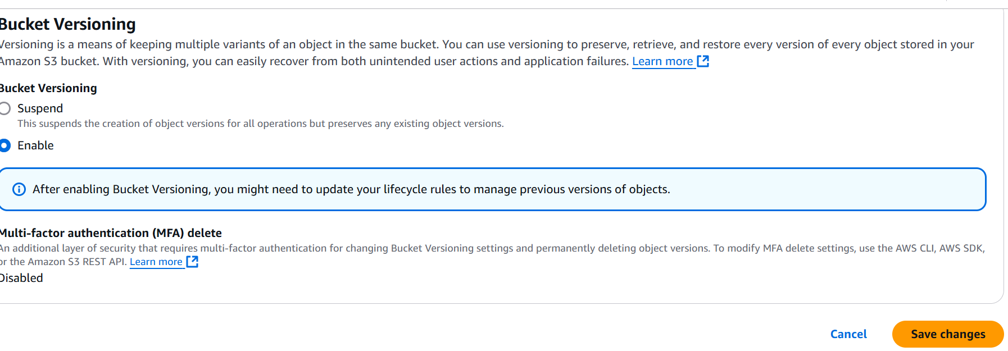

Ch**Step 4: Verify Versioning**

1. Click on the **Show Versions** tab in the S3 bucket.
2. You will see multiple versions of index.html, with the latest one marked as current.

**Step 5: Test Versioning with File Deletion**

1. Delete index.html from the bucket.
2. Check the **Show Versions** tab—previous versions will still be available.
3. You can restore the deleted file by selecting an earlier version.

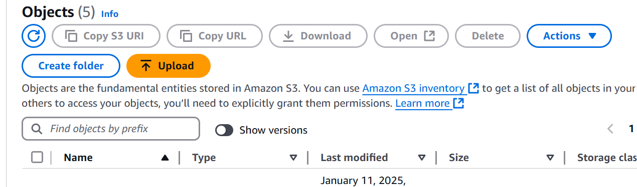

In case you delete it will go back to previous version, that is the way you will safegaurd